Floating River Water Quality Sensor Buoy — Project Specification
Version: 1.0 (Draft)
Location: Seattle, WA (freshwater river deployment)
Deployment duration target: 30 days unattended, solar-assisted

1. Project Overview
1.1 Purpose
Deploy a solar-powered, cellular-connected floating buoy in a river to continuously monitor water quality parameters relevant to public safety (swimmers, fishers, boaters) and environmental research (future microplastic module). Data is transmitted at regular intervals to a web server, stored, and made available via a real-time dashboard/GUI and eventually a public-facing app.
1.2 Goals
•Collect temperature, turbidity, dissolved oxygen (DO), and pH readings every 15 minutes.
•Transmit readings over cellular (LTE-M) to a remote web server.
•Operate unattended for 1 month on solar + battery power.
•Provide a real-time GUI for internal monitoring/analysis. •Design for future expansion: additional water-quality sensors, weather sensors, and a microplastic detection module (out of scope for v1).

1.3 Out of Scope for v1
•Microplastic detection/imaging module (planned as a future phase).
•Public-facing swimmer/boater app (v1 delivers internal GUI only).
•Bacteria/E. coli sensing (no real-time electronic method exists; would require lab sampling overlay).

2. System Architecture

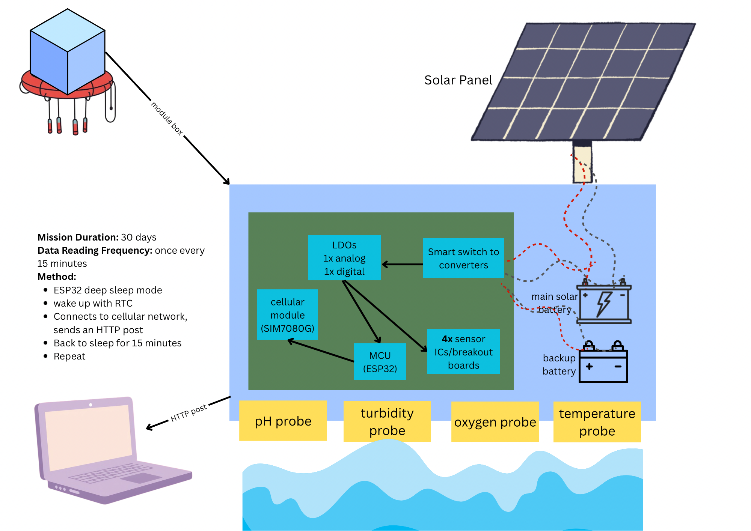

Traversal (how does it go back): go back by itself: using small propellers with brushed DC motors
Sensor corrosion: dipping chips — servo motors with mechanisms to dip the sensor probes in for a short period of time every 15 minutes — using pulley or ring method (or pipette mechanism)
For Andy and Shreyas:
- We evaluate how much the erosion affects the probes (determines how often maintenance is needed and how long to soak in the water)
- see how often needed to recalibrate stuff like pH probes

Two-tier power/compute model:
•Tier 1 (always cycling): ESP32 handles sensor reads, deep sleep, and cellular uplink on a 15-minute timer.
•Tier 2 (future, not in v1): Optional companion Raspberry Pi (or STM32 on the PCB) powered on briefly via relay for camera/ML-based microplastic imaging, on a longer interval.

3. Electrical Design
3.1 Core Compute & Connectivity
[Placeholder]

3.2 Sensors (v1 baseline)
[Placeholder]

Total sensor + core electronics budget target: ~$250–280 (under $300 constraint).
Known maintenance item: DO sensor membrane/electrolyte requires periodic replacement (~every few months) and recalibration against a known standard — flag for maintenance schedule (Section 7).

3.3 Power System
[Placeholder]

3.4 Antennas
•External SMA LTE antenna (puck or whip) — required for reliable signal from mid-river; do not rely on onboard stub antenna.
•External GPS antenna (SMA/IPEX) — supports drift/position confirmation.
•Antenna pigtail/extension if enclosure is non-RF-transparent (metal); not needed for plastic/fiberglass enclosures.
3.5 Local Data Storage
•MicroSD card (8–16GB) as an independent local log of every reading (timestamped), decoupled from cellular transmission success — acts as a backup if uplink fails for a cycle.

4. Mechanical Design
4.1 Buoy Platform
•Hull type: Catamaran-style dual-pontoon hull (HDPE or fiberglass) for stability in current, preferred over single round buoy.
•Ballast: Low-mounted weight to keep electronics enclosure upright and above waterline.
•Mooring: Anchor line to riverbed/bank, sized for expected flow velocity; includes breakaway/quick-release point to prevent total loss if snagged by debris.
4.2 Electronics Enclosure
•Rating: IP67/IP68, mounted above splash line, isolated from wet sampling components.
•Cable management: One cable gland (PG7/PG9) per penetration — sensor leads, antenna pigtail (if external).
•Environmental control: Desiccant packs inside; optional conformal coating on PCB as secondary humidity defense.
•Access: Hinged or quick-open lid for maintenance visits (filter cleaning, SD card retrieval, battery check).
4.3 Sensor Mounting
•Temperature, turbidity, DO, pH probes mounted in continuous flow (submerged directly in river current) — no isolation/batch chamber required for these parameters based on design review (batch sampling introduces DO drift and biofouling risk; in-situ continuous exposure is simpler and more representative).
•Probes connected via waterproof screw terminal or M12 connectors at the enclosure wall (serviceable without breaking watertight seal on wiring).
•Anti-biofouling consideration: probe placement should allow periodic manual wiping/cleaning during maintenance visits; optical windows (if added later for turbidity/fluorescence) may need a wiper or anti-fouling coating.

4.4 Solar Mounting
•Panel mounted top of enclosure, angled/positioned for maximum sun exposure, sized against expected Seattle solar irradiance with safety margin for cloudy days.

5. Software Design
5.1 Firmware (ESP32)
Sampling cycle (every 15 minutes):
- Wake from deep sleep via RTC timer (esp_sleep_enable_timer_wakeup).
- Power/read sensors (temperature, turbidity, pH, DO) via ADC/1-Wire.
- Log reading locally to microSD (timestamped).
- Attempt cellular connection (LTE-M via modem AT commands).
- Send reading via HTTP POST (JSON payload) to server API endpoint.
- On failure: retain data locally, retry next cycle or batch-send accumulated unsent readings.
- Return to deep sleep.

Example payload:
{
"device_id": "buoy-01",
"timestamp": "2026-07-22T14:15:00Z",
"temperature_c": 18.3,
"turbidity_ntu": 12.4,
"ph": 7.2,
"do_mgL": 8.1,
"battery_v": 3.87
}

5.2 Backend / Server
•REST API endpoint (e.g., POST /api/readings) accepting JSON payloads from the buoy.
•Time-series database for storage: InfluxDB or PostgreSQL/TimescaleDB.
•Basic validation/sanity-check layer (reject out-of-range values, flag sensor fault conditions e.g. stuck readings).
5.3 GUI / Dashboard (v1 — internal use)
•Recommended: Grafana connected directly to the time-series database — provides real-time charts, historical trends, and threshold-based alerting with minimal custom development.
•Alternative/future: custom web app (React or HTML/JS + Chart.js/Recharts) polling the API, for a more tailored public-facing experience later.
•Prototyping option: Streamlit/Dash for quick internal data exploration before committing to final GUI design.
5.4 Future Software Scope (not v1)
•Public app with swim/fish/boat safety indicators (e.g., algae bloom alerts via future BGA sensor, current speed for boaters).
•Onboard or server-side ML pipeline for microplastic image classification (paired with future camera module).
•Alert/notification system (threshold-based push alerts for abnormal readings).

6. Data & Telemetry Summary
[Placeholder]

7. Maintenance Plan
[Placeholder]

8. Risk & Open Items
•Cellular coverage at exact deployment site — must be field-verified with the actual T-SIM7000G + SIM before final mooring (metro-level coverage maps don’t guarantee signal in canyons/dense foliage/etc.).
•DO sensor cost dominates budget — electrochemical DO ($169) accounts for the majority of the sub-$300 sensor budget; fluorescence/optical DO would improve long-term maintenance burden but exceeds budget for v1.
•Biofouling — no active anti-fouling mechanism in v1 beyond manual cleaning; may need revisiting if maintenance interval needs to extend beyond 2–4 weeks.
•Enclosure material vs. antenna performance — confirm enclosure material is RF-transparent, or plan for external antenna mounting.
•Solar sizing — needs final calculation against Seattle-specific seasonal irradiance data and confirmed ESP32 duty-cycle power draw before finalizing panel wattage.

9. Bill of Materials Summary (v1 Core Build)
[Placeholder]
[link to Google sheets]

10. Next Steps
- Finalize BOM and place orders for core electronics + sensors.
- Bench-test full sensor + ESP32 + cellular stack before field enclosure integration.
- Field-test cellular signal (LTE-M) at actual deployment site.
- Build and test firmware sleep/wake/transmit cycle for power budget validation.
- Assemble mechanical enclosure and mounting; waterproof and pressure-test before deployment.
- Stand up backend API + database + Grafana dashboard.
- Deploy, monitor first 48–72 hours closely, then transition to scheduled maintenance cadence.

https://claude.ai/share/1340bf79-e1f6-4113-9fab-5cc55bac7f31 <- chat link with the spec in a way
https://claude.ai/share/a8a0222f-3c0d-4f63-9f5b-978bcf6b7f2a <- chat link to brainstorm and research

Worth reaching out oceanography professors and UWROV

The robot will be used in rivers, lakes, and reservoirs

Sensor integration - you want real-time sensor monitoring system to know both what you’re treating and if your treatment improves the condition

Build a river intelligence service, with the robot being the most visible component.

River evaluations + cleaning service
- Have river cleaning robots, but not a service thing are a research thing
- Build platform to offer that service
- Target evaluating some river in washington

Questions that help to define this project:
- what water structures are we dealing with?
- what are the substances in these waters and how do we measure/evaluate them?
  - how do we filter out those subtances → how those subtances affect human body (microplastic)
  - how do those substances affect eco system - plants and animals
- what exactly would the robot do? Where do we deploy the robot?
- What else do we need other than that robot
- what seasonal

First Task: Build integrated sensor
- How do you power it
  - Not LIPO battery
  - run it in cycles
    - use a real time clock or alarm
- What to measure
  - Physical (temperature)
    - Temperature
    - Erosion
    - flow/depth
  - Chemical
    - pH (Amazon.com: Ph Sensor) (atlas ph sensor)
    - Oxygen levels (oxygen sensor)

  - Biological
    - Nitrate/phosphate
    - Chlorophyll
    - Bacteria
  - Man-Made Pollutant
    - Microplastics (safe level or not) - particle sizes
    - Heavy metals
    - PFAS/PCBs
  - Environmental
    - Pressure
    - Gps
    - camera?

River B

River A
SM
SM

Lake A
SM

Utility Spec:
- Need to CAD it (onshape?)
- Needs to send data to the web so we can view it remotely (Raspberry Pi)
  - Needs to store data in a SD card
- Needs to float and sink on remote demand (submarine mechanics)
- Needs to snap into normal mode from power saving mode on remote demand
- How to fish it back up?

- needs to be waterproof and erosion-resistant
  - make a waterproof shell, put it in a water bucket overnight, next day see if it leaks in
- effect on water and interaction with the wildlife- if there’s a way to do it safely

Outreach Note Log:

Tell us about your startup:
Problem, , Features, Value, Benefit

Apply to stuff:
Our goal focuses on providing low-cost solutions for the evaluation and cleansing of water in various freshwater bodies. We are developing a compact multi-sensor device to measure different properties of each water body being evaluated, which include but are not restricted to: pH level, oxygen level, biological composition (chlorophyll, bacteria, nitrate/phosphate), and man-made pollutants (microplastics, heavy metals, PFAs/PCBs).
To cleanse the water body, a subautonomous submarine will be deployed to collect garbage on the water surface and at the bottom of the water, and will measure the erosion level and map the flow and depth of the water body. Afterwards, efforts will be made to come up with solutions to eliminate the dissolved pollutant and other small harmful compositions that aren't able to be picked up by the submarine.

Freshwater ecosystems are increasingly threatened by pollution, yet monitoring and restoring water quality often requires expensive equipment and time-consuming fieldwork. Our project aims to make freshwater assessment and cleanup more accessible by combining a compact, low-cost water quality sensor with a semi-autonomous underwater vehicle. Together, the system can monitor key indicators such as water chemistry, biological activity, and harmful pollutants while mapping the environment and removing debris from both the surface and underwater. By bringing environmental sensing, data collection, and cleanup into a single platform, we hope to provide researchers, industry, environmental organizations, and local communities with an affordable, scalable tool to better understand, protect, and restore freshwater ecosystems.

Email:
Hello XYZ,

The current
Our goal focuses on providing low-cost solutions for the evaluation and cleansing of water in various freshwater bodies. We are developing a compact multi-sensor device to measure different properties of each water body being evaluated, which include but are not restricted to: pH level, oxygen level, biological composition (chlorophyll, bacteria, nitrate/phosphate), and man-made pollutants (microplastics, heavy metals, PFAs/PCBs).
To cleanse the water body, a subautonomous submarine will be deployed to collect garbage on the water surface and at the bottom of the water, and will measure the erosion level and map the flow and depth of the water body. Afterwards, efforts will be made to come up with solutions to eliminate the dissolved pollutant and other small harmful compositions that aren't able to be picked up by the submarine.

Claude:
Subject: Mentorship & Collaboration Inquiry – Freshwater Monitoring & Remediation Startup

Hi [Name],

I'm a graduate EE student at the University of Washington, and I'm working with a small team on a freshwater monitoring and remediation platform. I came across your work and wanted to reach out directly.

The project has two main phases. The first phase is building a compact, remote multi-sensor device for in-field water quality measurement (e.g. pH, oxygen, chlorophyll, nitrate/phosphate), and contaminants (e.g. microplastics, heavy metals, and PFAs/PCBs).
The second phase of this project is to develop a semi-autonomous underwater vehicle that uses the data collected from the remote sensor and collects debris from the water surface and bottom of the water body, while also mapping depth, flow, and erosion. The data from both feeds into a remediation strategy for the things that require more than a physical arm to filter through.

Where we could really use help is on the vehicle structures, sensor integration, and algorithms, gmaand honestly just learning from people who've actually deployed these systems in the field. We're not looking to take up much of your time, but even a short conversation would go a long way.

Would you be open to a quick 20 minute call sometime?

Best,
[Name]
Garbobot Team

Meeting Notes:
Venture Well Competition/Program
Intent:
- We want to do this because

Development Phase:
- Phase 1: Sensor system
- Phase 2: Subautonomous submarine
- Phase 3: Biological/Chemical solutions

Why CoMotion?
- We want to bridge our knowledge gaps by spreading the word to the environmental departments and using CoMotion as our platform
- We want to have access to lab equipment since we’re 100% self-funded at the moment, with limited resources

Who are potential customers?
- nonprofit
- people who manage areas of water - national parks, private homes
- areas with unsafe water
- areas with a lot of debris

Business plan?
- Because we’re in college - pitch to the oceanography department - see how they turn out; if successful, expand to local - King County
- Have a timeline: We’ll have a prototype by around October / end of the year 2026

Our questions:
- Broader question: Are people in the CoMotion labs having similar interests? Can they help with our project?

